**3. Use the same rest countries and print all countries name, region, sub region and population**

**Printing all countries names:**

**// xml-http request**

**//set up our HTTP Request**

**var xhr = new XMLHttpRequest();**

**//we will send a instruction by applying on load**

**xhr.onload = function() {**

**//status checking 200-400**

**if (xhr.status >= 200 && xhr.status<= 400){**

**var f = JSON.parse(this.response);**

**//by using array concept checking and printing name of each country**

**for(var i=0;i<f.length;i++){**

**console.log(f[i].name);**

**}**

**} else {**

**consol.log(xhr.responseText)**

**}**

**};**

**//create and send some request to api**

**// we required one is request type and another is URL**

**xhr.open("GET", "https://restcountries.eu/rest/v2")**

**xhr.send();**

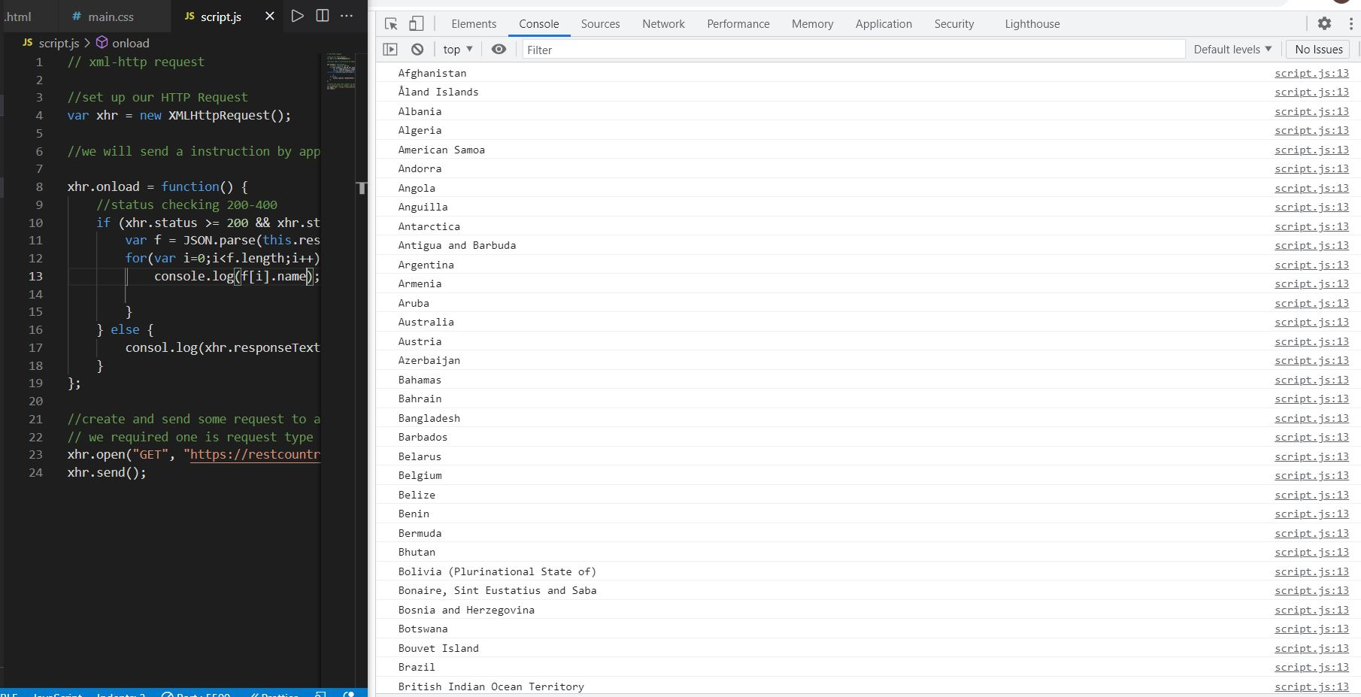

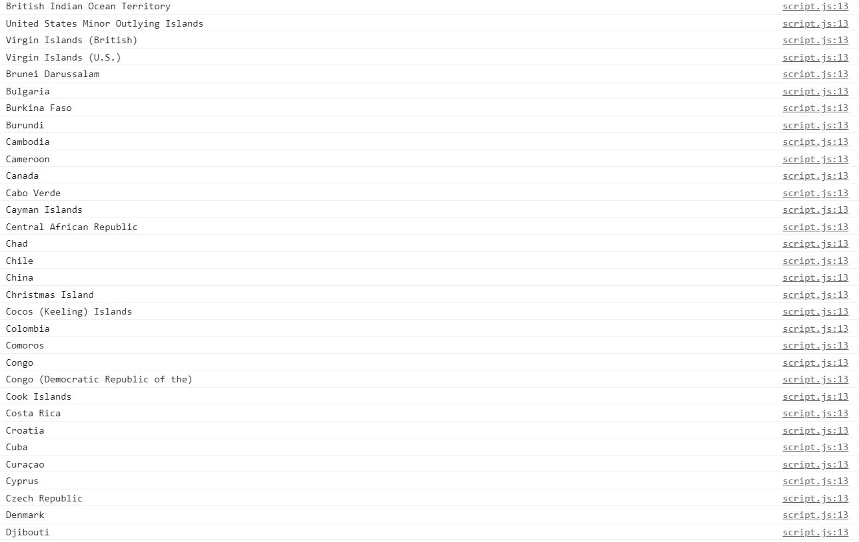

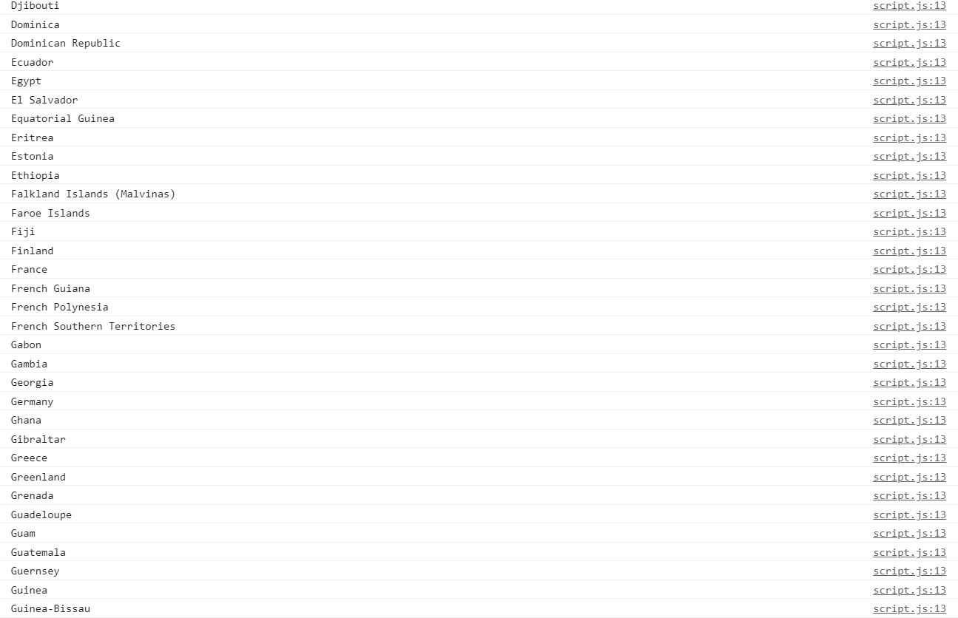

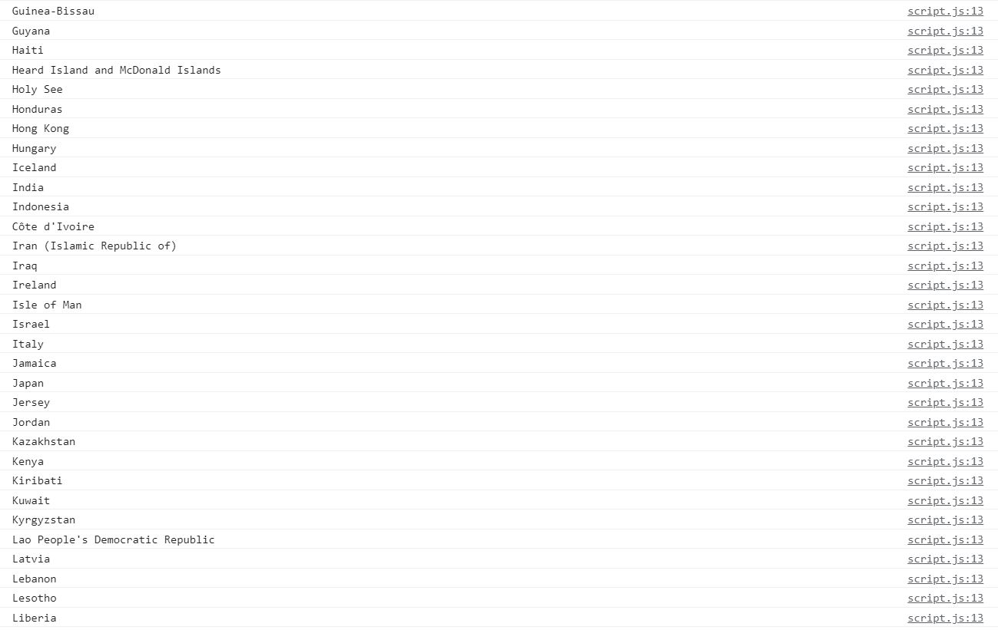

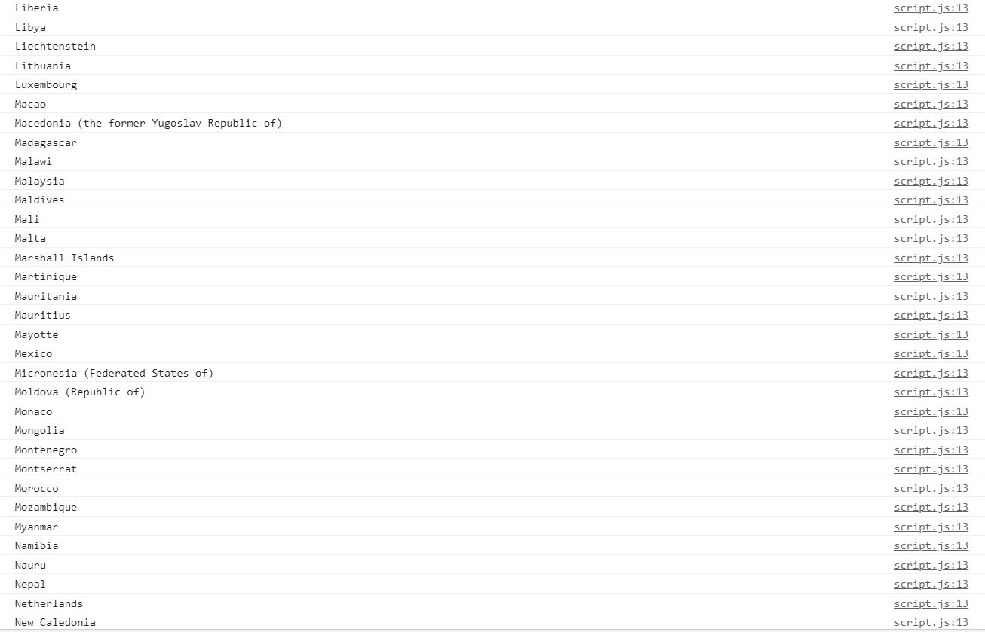

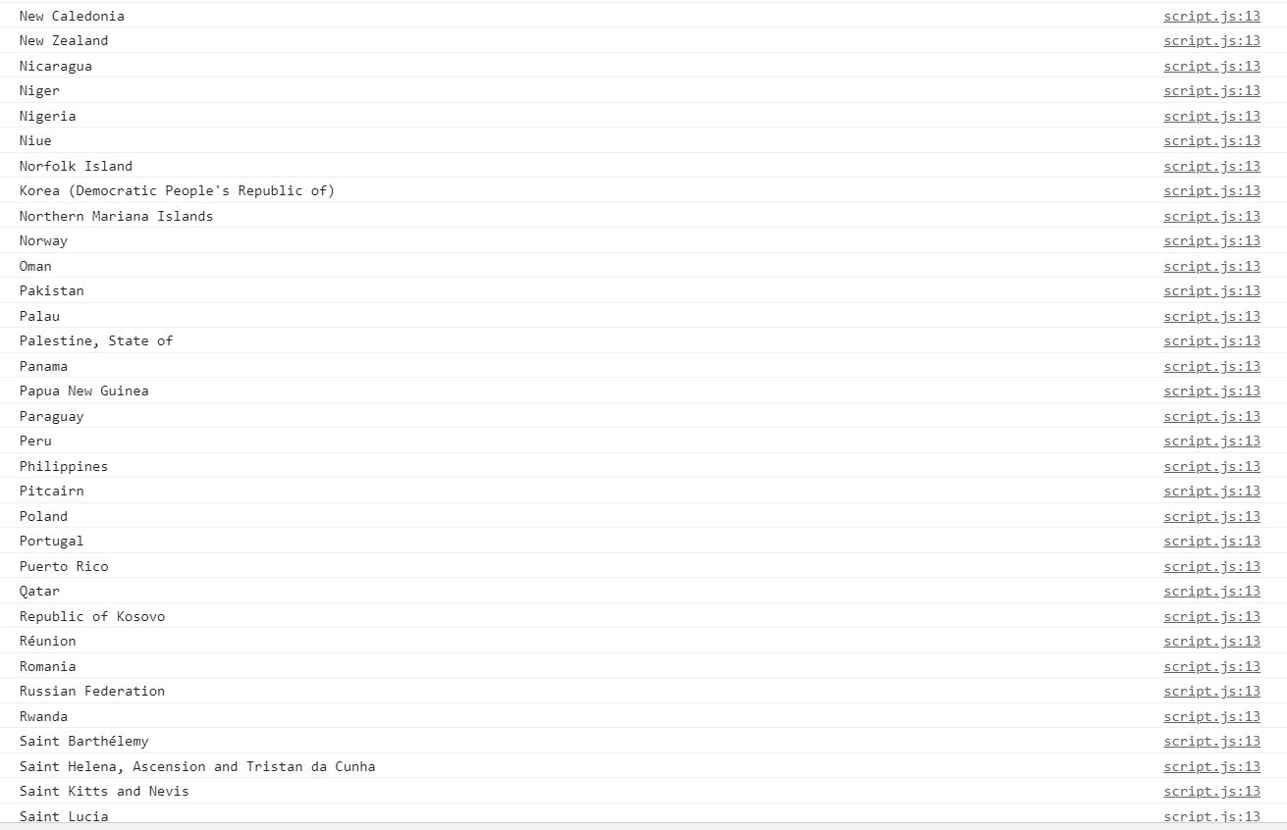

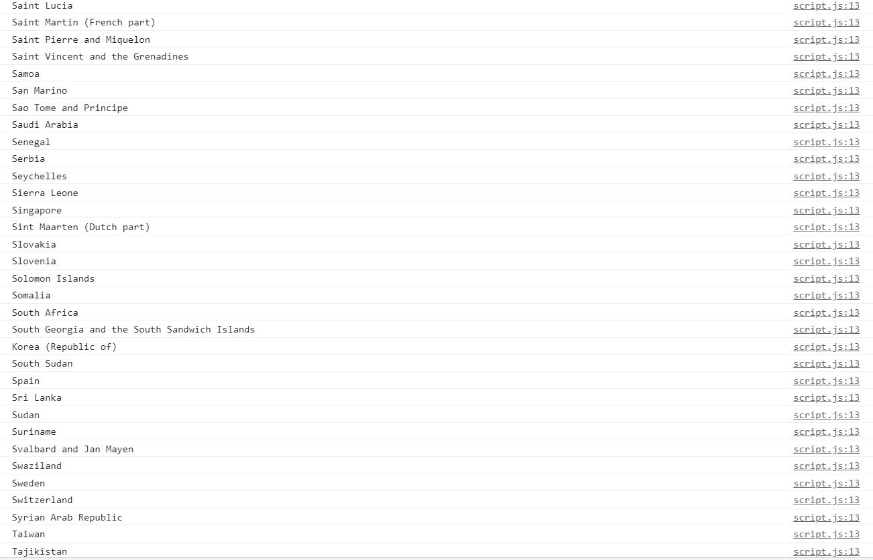

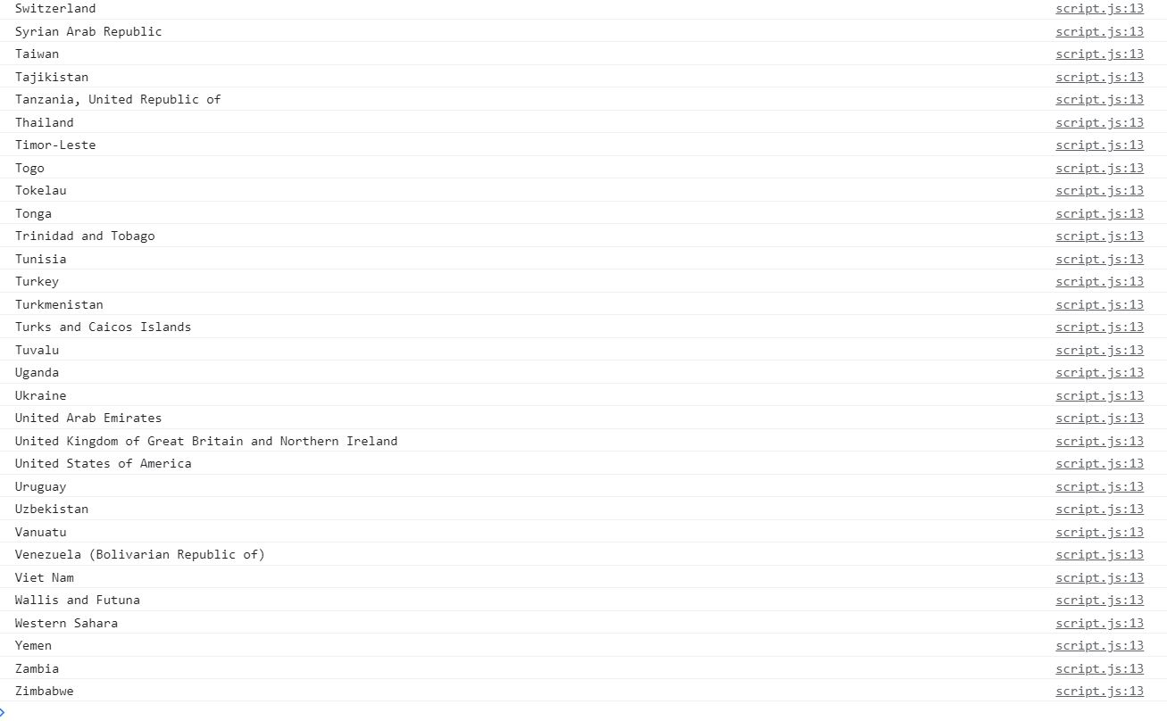

**Printing all countries region:**

**// xml-http request**

**//set up our HTTP Request**

**var xhr = new XMLHttpRequest();**

**//we will send a instruction by applying on load**

**xhr.onload = function() {**

**//status checking 200-400**

**if (xhr.status >= 200 && xhr.status<= 400){**

**var f = JSON.parse(this.response);**

**//by using array concept checking and printing region**

**for(var i=0;i<f.length;i++){**

**console.log(f[i].region);**

**}**

**} else {**

**consol.log(xhr.responseText)**

**}**

**};**

**//create and send some request to api**

**// we required one is request type and another is URL**

**xhr.open("GET", "https://restcountries.eu/rest/v2")**

**xhr.send();**

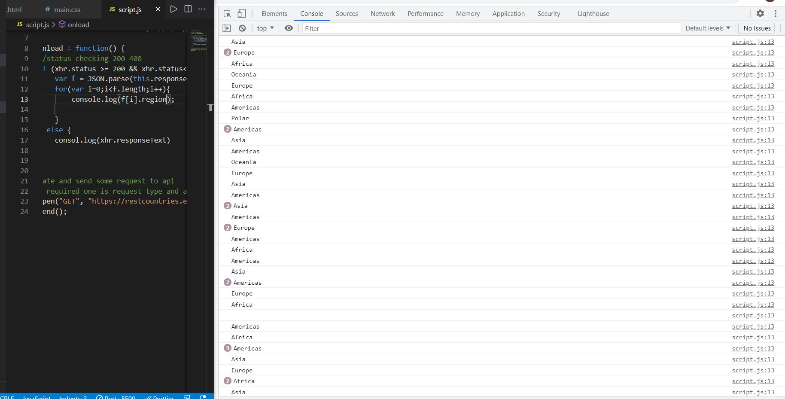

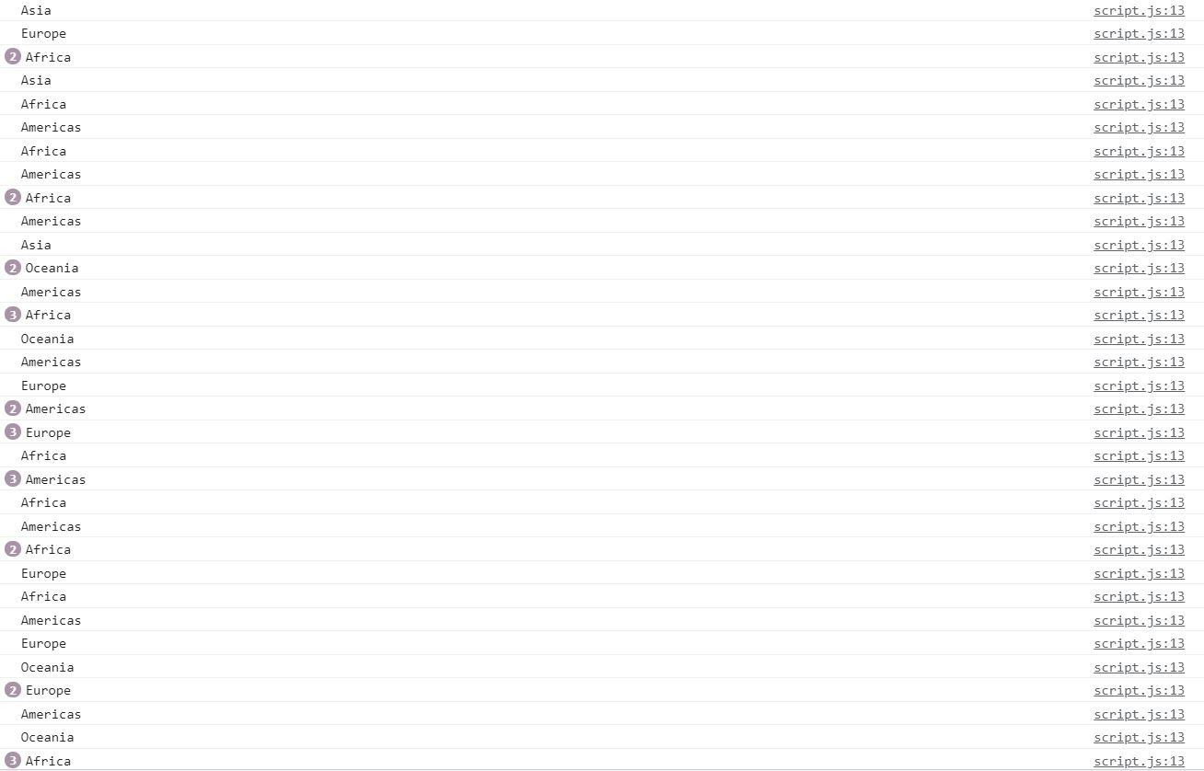

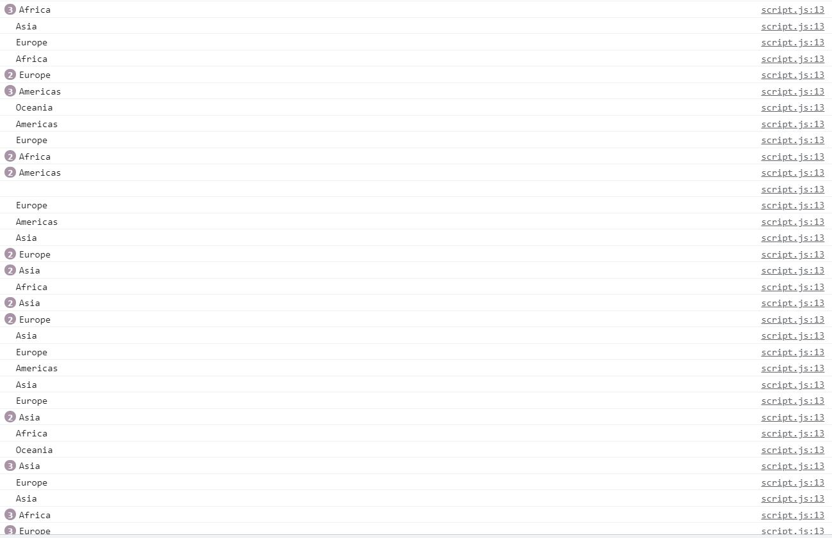

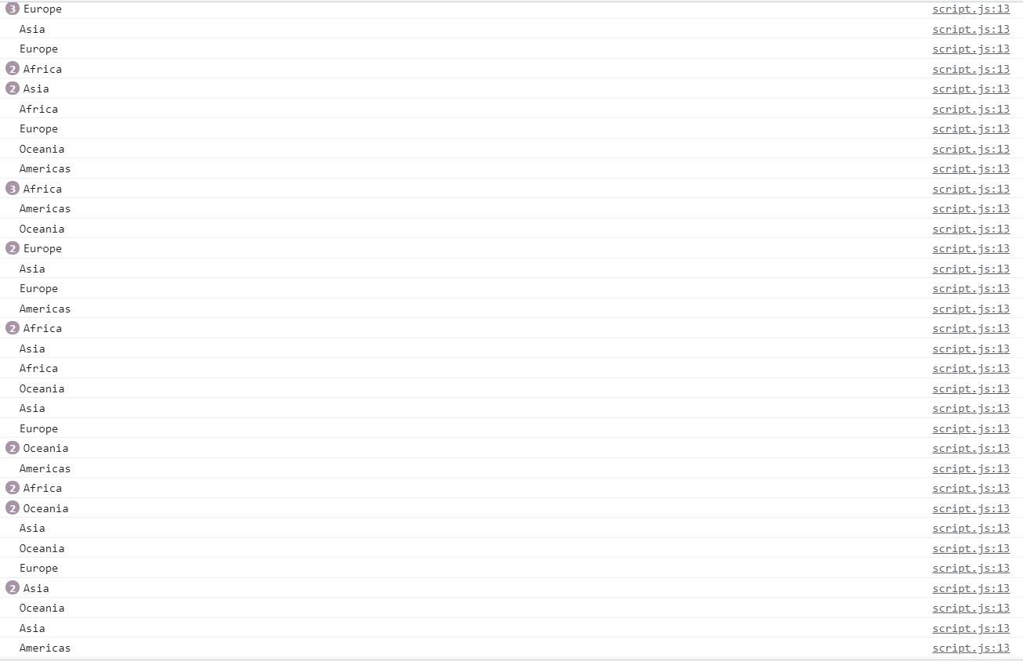

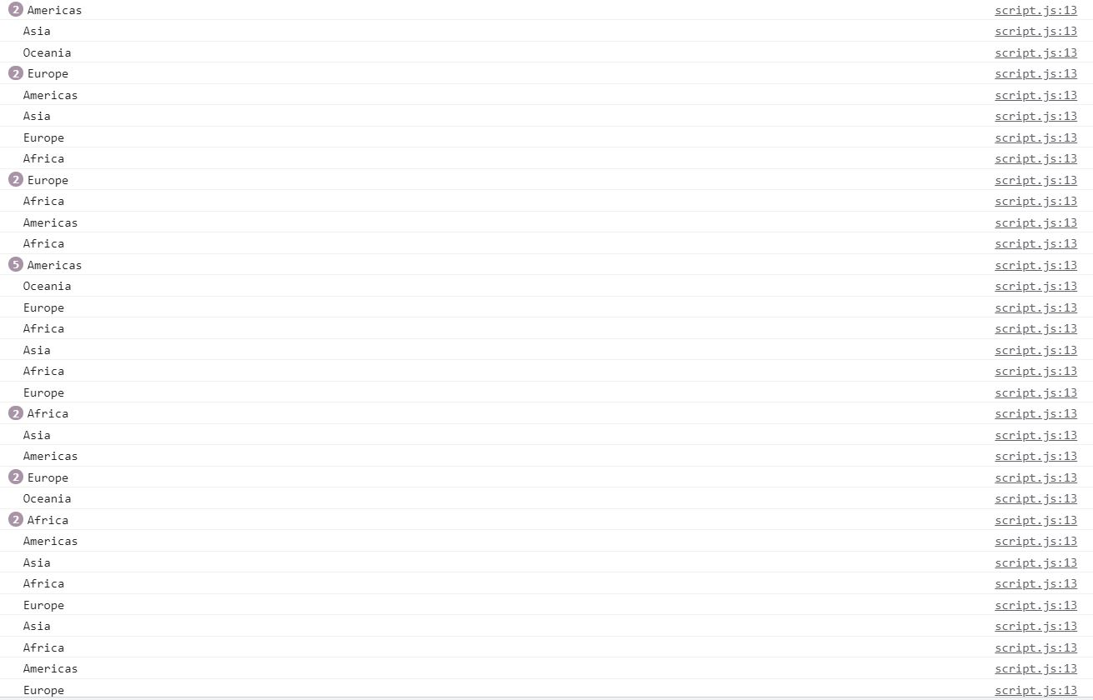

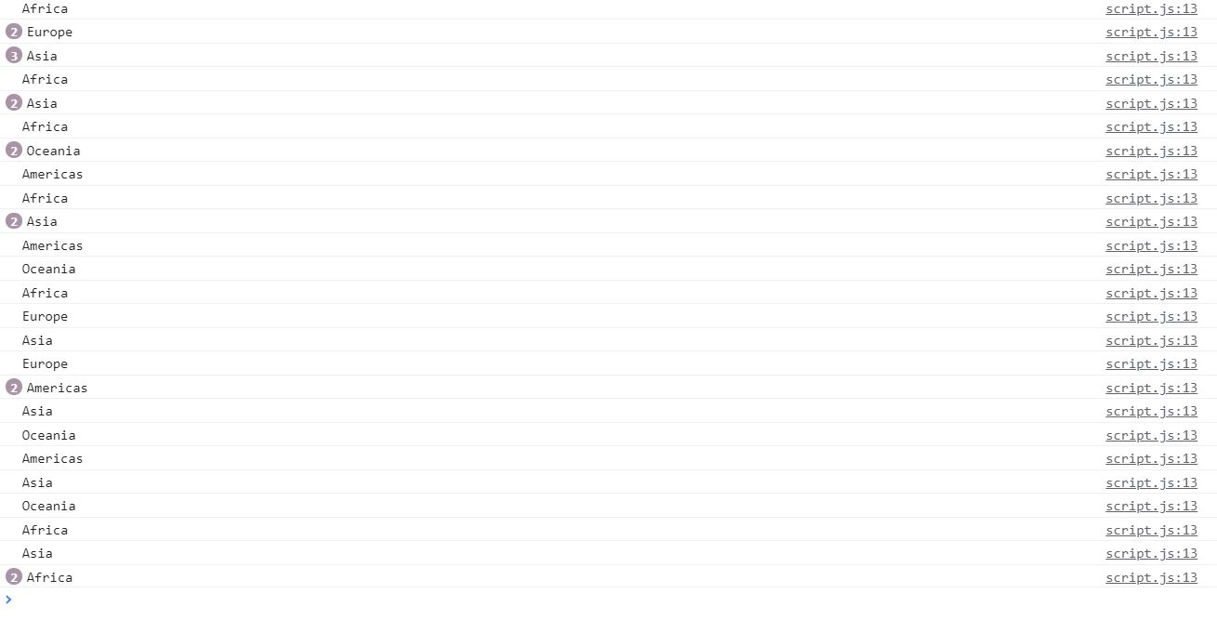

**Printing all countries sub region:**

**// xml-http request**

**//set up our HTTP Request**

**var xhr = new XMLHttpRequest();**

**//we will send a instruction by applying on load**

**xhr.onload = function() {**

**//status checking 200-400**

**if (xhr.status >= 200 && xhr.status<= 400){**

**var f = JSON.parse(this.response);**

**//by using array concept checking and printing subregion**

**for(var i=0;i<f.length;i++){**

**console.log(f[i].subregion);**

**}**

**} else {**

**consol.log(xhr.responseText)**

**}**

**};**

**//create and send some request to api**

**// we required one is request type and another is URL**

**xhr.open("GET", "https://restcountries.eu/rest/v2")**

**xhr.send();**

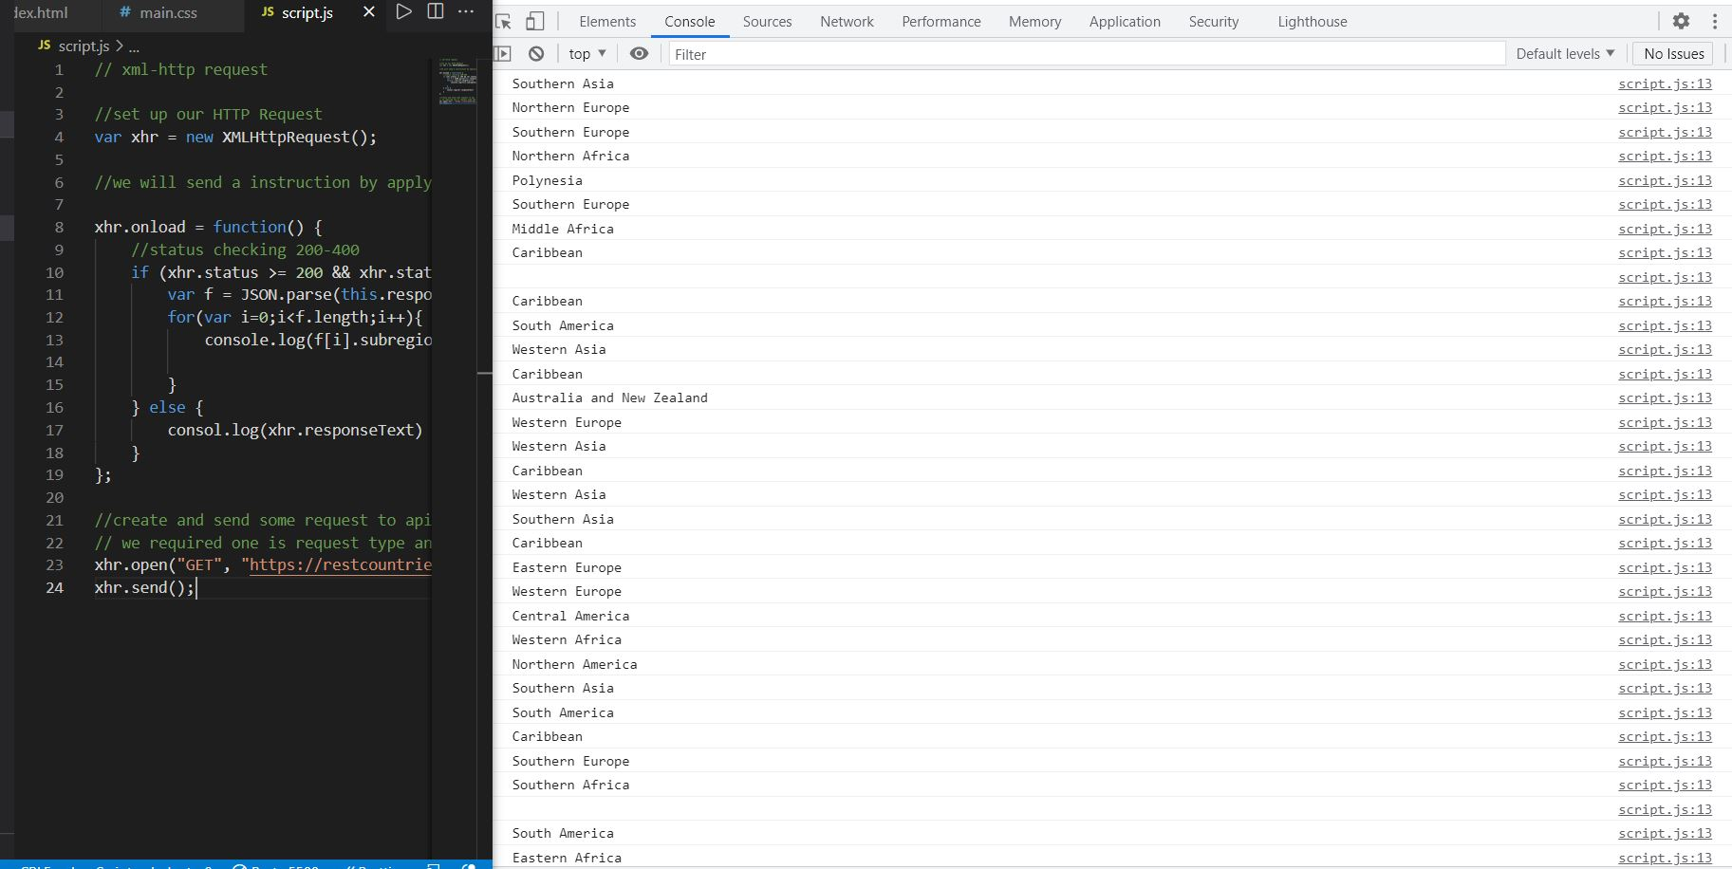

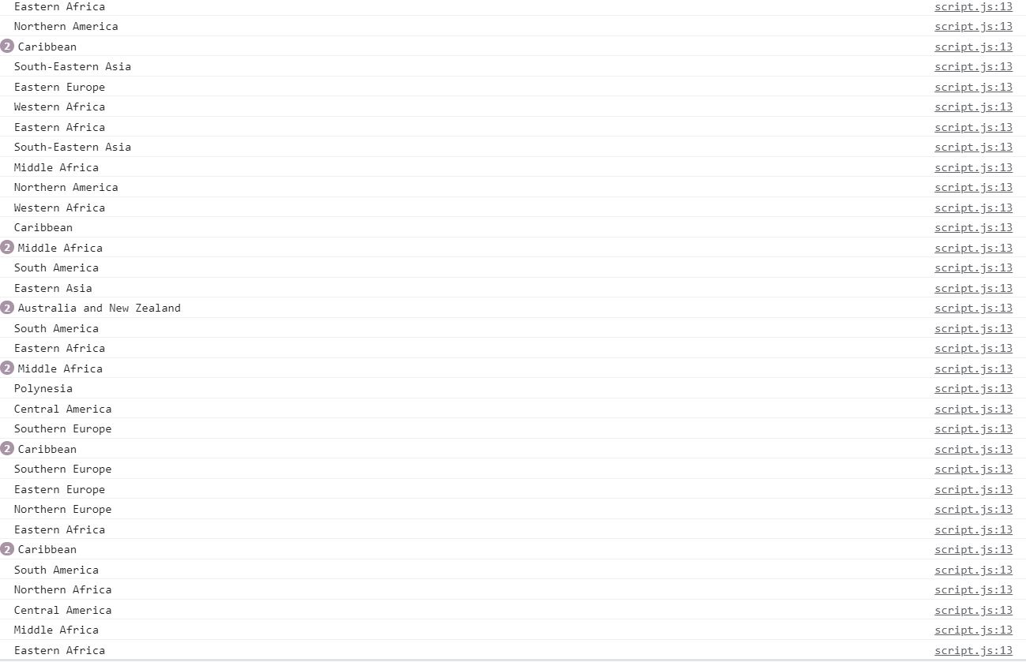

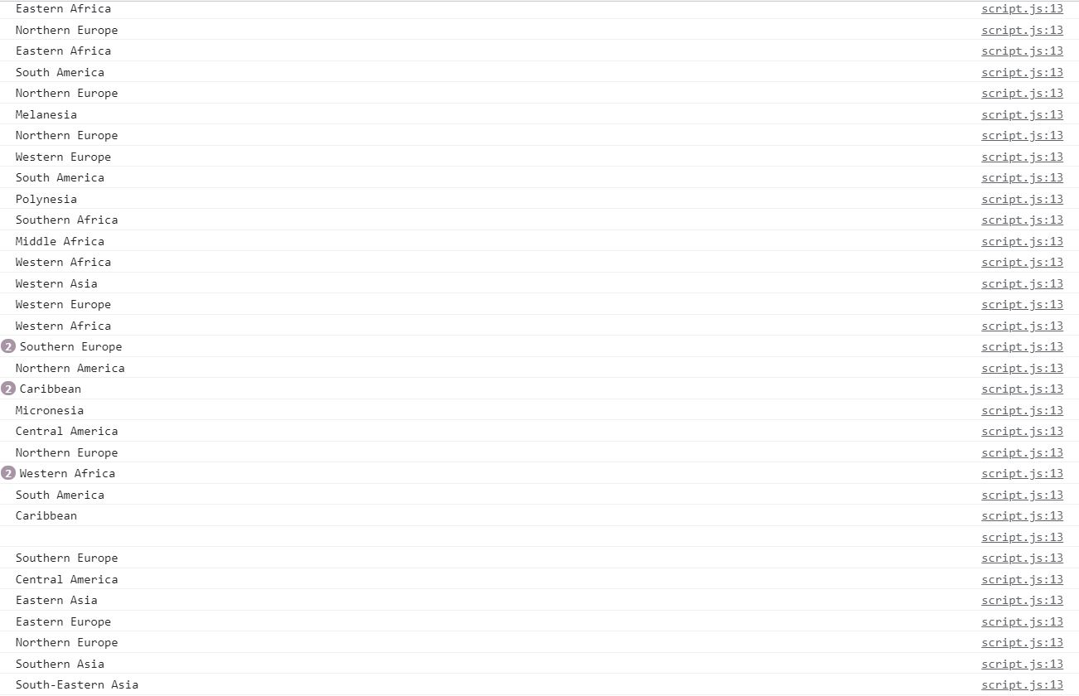

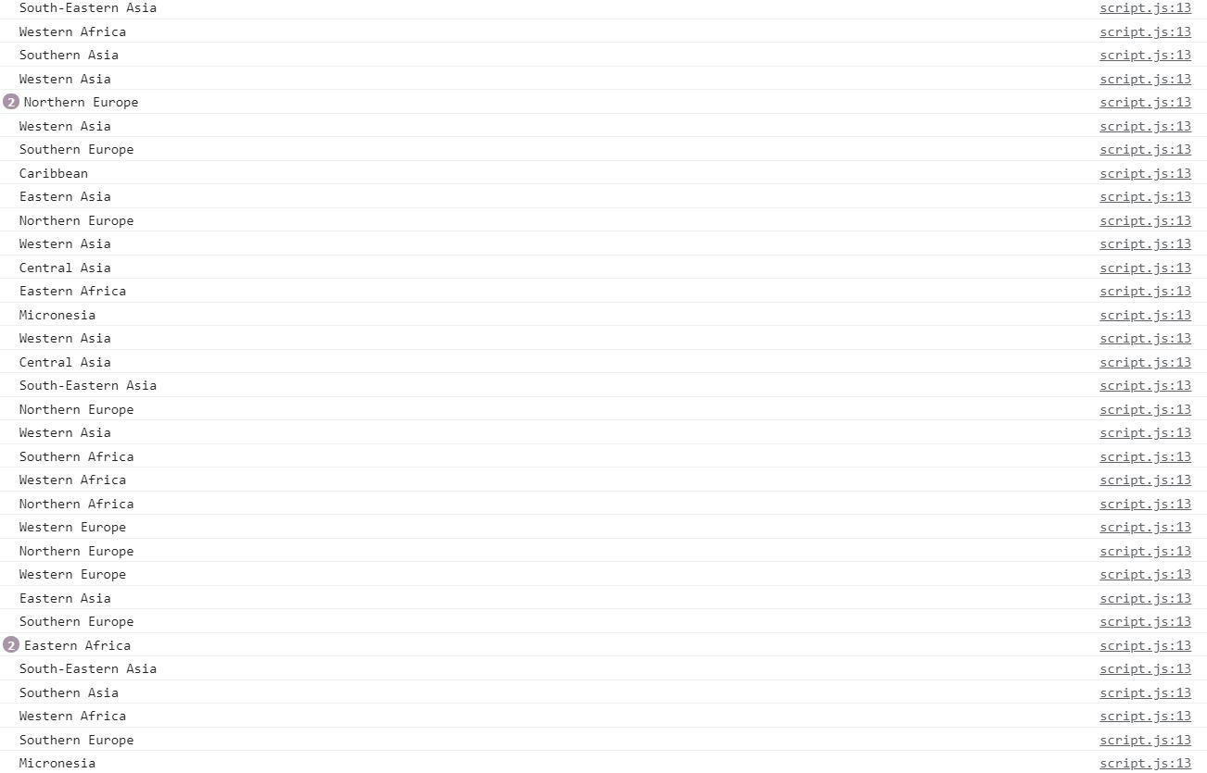

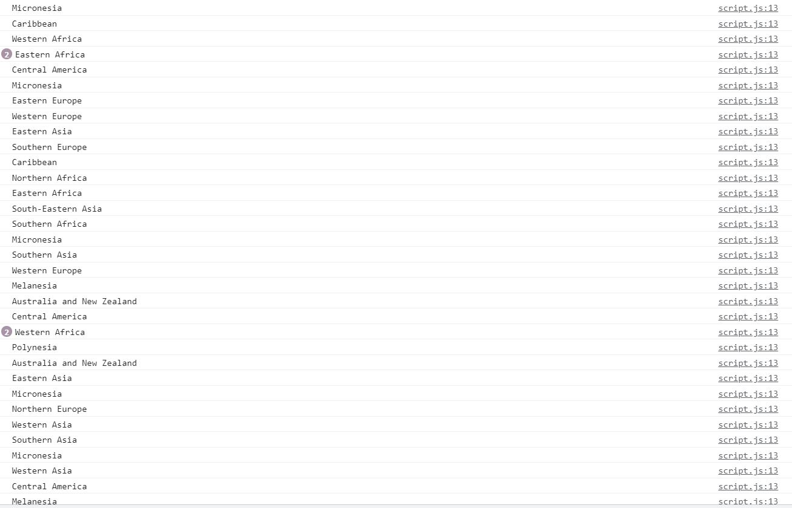

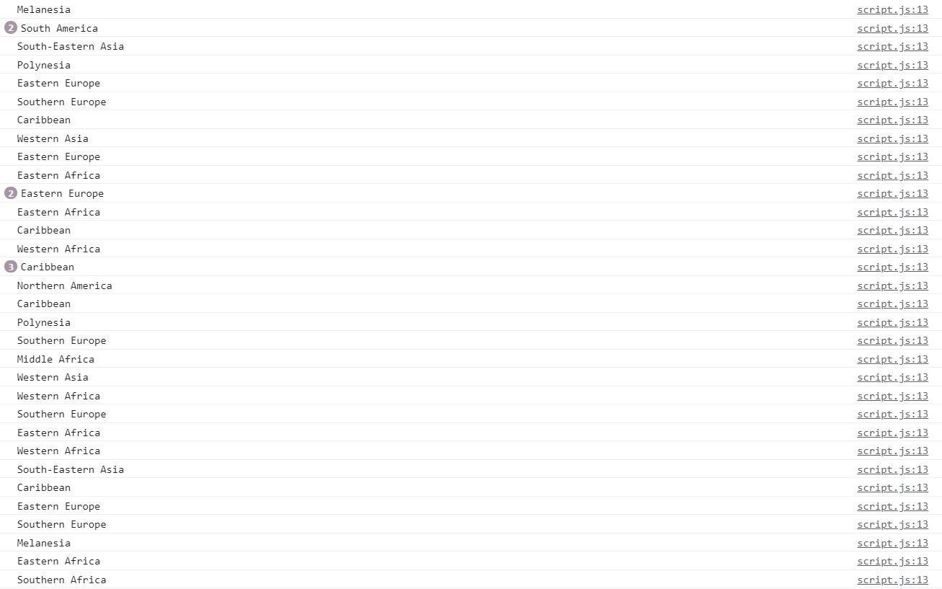

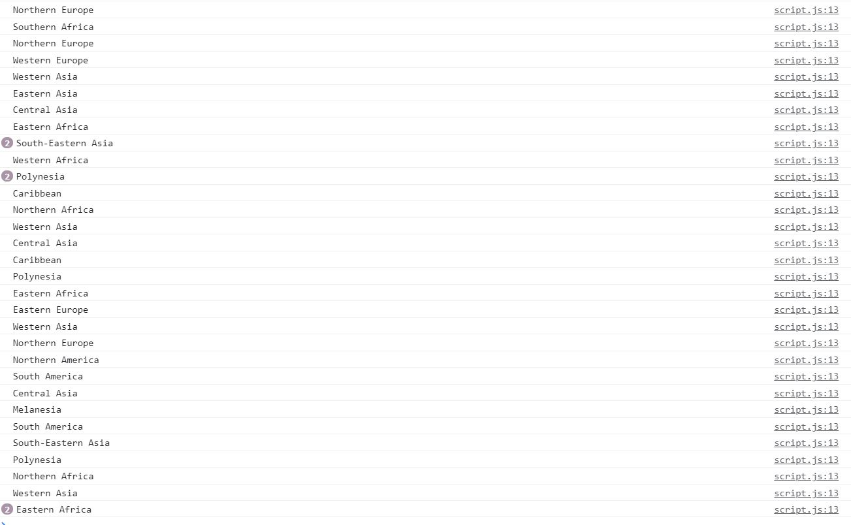

**Printing all countries population:**

**// xml-http request**

**//set up our HTTP Request**

**var xhr = new XMLHttpRequest();**

**//we will send a instruction by applying on load**

**xhr.onload = function() {**

**//status checking 200-400**

**if (xhr.status >= 200 && xhr.status<= 400){**

**var f = JSON.parse(this.response);**

**//by using array concept checking and printing population**

**for(var i=0;i<f.length;i++){**

**console.log(f[i].population);**

**}**

**} else {**

**consol.log(xhr.responseText)**

**}**

**};**

**//create and send some request to api**

**// we required one is request type and another is URL**

**xhr.open("GET", "https://restcountries.eu/rest/v2")**

**xhr.send();**

